Caenorhabditis elegans: understanding its movement through the screen of the mutant roller phenotype
Chad Marshall
BIOL 3452.507
Lab Instructor: Mary Ladage
November 10, 2012

TABLE OF CONTENTS:

Abstract 3
Introduction 3
Research Design 7
Instruments 8
Procedure 9
Expected Results 10
References 11

ABSTRACT:
In our study, we screen for the roller phenotype in Caenorhabditis elegans. Worms that exhibit this property can be observed twisting into a helix along their longitudinal axis. By screening for the roller phenotype among mutagenized worms, we serve multiple interests. First, we address our hypothesis: there are specific genes within the C. elegans genome that code for the biological process of movement and therefore are responsible for the roller phenotype. After isolating mutant roller worms, we can then cross-breed them with wild type worms to test the nature in which the gene is inherited (i.e. dominant or variable penetrance). We can also map the gene associated with producing the roller phenotype, which could then help elucidate the gene homolog in humans and lead to the future treatment of certain human diseases.

INTRODUCTION:
Oftentimes, much is learned about a biological process occurring in humans by studying the same process in a model organism. In selecting the right model, there are several criteria. One, the model should be the simplest organism with the same traits of interest. It is also helpful if the model is easily manipulated and small in size, so it can be grown within the confines of a laboratory (Jorgensen and Mango, 2002). A model that exudes rapid development with short cycles is also beneficial (Padilla et al., 2012). For this experiment we have chosen to study the biological process of movement, and we have selected the nematode Caenorhabditis elegans as our model organism. C. elegans makes an ideal model organism for many reasons. Fully grown adults are quite small (1 mm in length), and their life cycle is about 3.5 days when kept at 20°C (Brenner, 1974). C. elegans also has many of the same tissue and organs of other complex organisms such as muscles, gonads, a gastrointestinal tract, epidermis, and a nervous system (Jorgensen and Mango, 2002). Average life span of C. elegans is only about 2-3 weeks, and their entire genome containing over 20,000 genes has already been sequenced. About one-third of these genes have mammalian counterparts (Jorgensen and Mango, 2002). Consequently, much is known about the organism, but there is still much to be learned as fewer than 10% of the 20,000 genes have been defined by mutation.
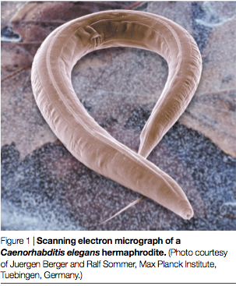
Figure 1: Caenorhabditis elegans (Jorgensen and Mango, 2002)
As mentioned earlier, we are studying movement, and to do this we will carry out a forward genetic screen in which we will isolate mutant worms that show differences in phenotypes associated with movement. Prior to isolation, we will first induce mutations in the worms by subjecting them to ethyl methanesulfonate (EMS). Thanks to the pioneering work of Sydney Brenner, we know that EMS is known to induce several hundred different mutations in C. elegans, with 77 alone known to alter movement of the worm (Brenner, 1974) and many others still to be discovered. The phenotype we are focusing on in this experiment is known as roller. A mutant showing the roller phenotype rotates around its longitudinal axis as it moves. This forces the worm to move in a circular path, which is easily recognized by the track it leaves in the bacterial lawn (Brenner, 1974).
The rolling action of the mutated worms can be further explained in terms of its altered anatomy. The cuticle of the worm describes its complex extracellular structure, which encases its internal organs. It has been found that in roller mutants, the external cuticle as well as the internal organs are helically twisted. Evidence suggests that this is the primary alteration in the roller mutants (Cox et al, 1980).

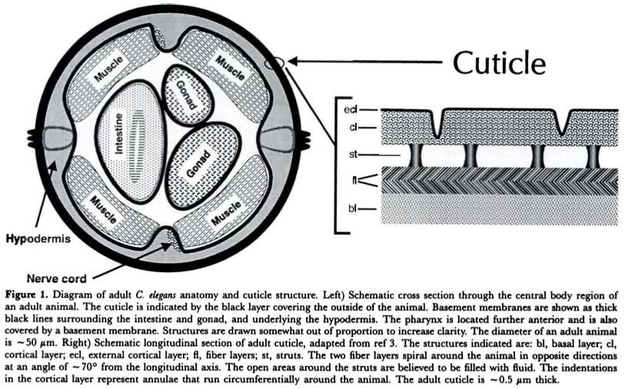
Figure 2: cross section of C. elegans cuticle structure (Kramer, 1994)
When isolating the roller mutants, it will be valuable to know when the roller phenotype is displayed during development of the worm. Roller behavior is typically not seen until the worm reaches the L4 or adult stage of development; however, as shown in the table below, there are some exceptions.

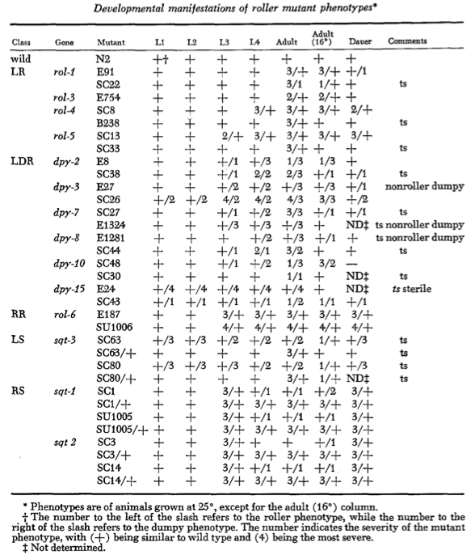
Table 1: List of 14 genes known to give roller phenotypes and their developmental manifestations (Cox et al., 1980)

Learning about the process of movement in C. elegans has merit on its own, but more importantly, we are seeking to learn more about human processes through our study of C. elegans. Prior research shows there are connections between the two. Specifically, there is a relationship between the rol-6 gene in C. elegans and a human collagen alpha 1 (III) chain precursor, or COL3A1 (Wormbase, 2012). This gene encodes for a type 3 collagen, which is a major component of the extracellular matrix in a variety of our internal organs and skin. When the COL3A1 gene is mutated, it causes a disease known as type IV Ehlers-Danlos syndrome, which can lead to aortic rupture in early adult life (OMIM, 2012). Currently, there is no cure for Ehlers-Danlos syndrome, but with continued research using the C. elegans as a model organism, this status could one day change.
Researchers have also made a connection between a cartilage associated protein (CRTAP) existing in humans and in C. elegans (NCBI, 2012). Although this is not directly related to the roller phenotype, a mutation in the CRTAP gene causes a disorder of the connective tissues in humans (NCBI, 2012) Known as osteogenesis imperfecta, this disorder causes major phenotypic features such as bone fragility, low bone mass, deafness, and ligamental laxity (Cole and Dalgleish, 1995).

RESEARCH DESIGN:
Our research will be conducted within the timeframe of about 1 week. It has been designed, so that it can be easily reproduced in college genetics laboratories. We will mutagenize a stock of about 50 wild-type L4 to young adult hermaphrodite worms. From that stock, we will place 1 worm on each of five NGM plates, coated with the OP50 strain of E. coli. These foundational worms will serve as our parent generation, P_{0.} Once these worms have reproduced and eggs are visible on the plates, the P₀’s will be moved to another 5 plates. This will ensure that we have ample offspring of the F₁ generation in case issues such as contamination or starvation occur. Also, to safeguard against starvation, we will transport only 5-7 F₁ worms to new plates to lay eggs, which will hatch to become the F₂ generation. In addition to providing the worms with an ample food source, moving each successive generation of worms to fresh plates will allow us to more efficiently keep track of the offspring and the mutations observed in each generation. This is why it is imperative to maintain a strict schedule during the course of the experiment. Checking on the worms daily, we can see exactly when eggs are laid and when parent worms need to be removed in order to prevent mixing of generations.

INSTRUMENTS:
Ethyl methanesulfonate (EMS) is a mutagen, which causes mutation by altering guanine and thereby leading to abnormal base pairing with thymine (Padilla et al., 2012). We will use this chemical to induce mutation in the worms.
The worms will grow and reproduce on nematode growth media (NGM) plates. The NGM is aseptic and seeded with OP50, a strain of the bacteria E. coli. OP50 will provide the worms with a source of food. This strain of E. coli is selected in particular because of its non-pathogenic nature and dependency on uracil. The plate medium contains limited uracil, so this prevents overgrowth of the bacterial lawn, which would normally create difficulty for the worms to move (Brenner, 1974).
For transfer of worms, we will use a worm pick made in the laboratory with approximately a 1-inch piece of 32 gauge platinum wire and a glass Pasture pipet. Platinum is used because of its durability and also its ability to heat and cool quickly. These qualities allow for the wire to be fashioned to personal preference as well as to be flamed often to avoid contamination of the plates when picking and transferring worms. (Padilla et al., 2012).
We will observe the worms on the NGM plates using stereomicroscopes. While they are low power (2-4x), they provide sufficient magnification to screen for mutant phenotypes.
To further prevent contamination of the plates, we will store them in a plastic bag, which will be placed in a shoebox. This shoebox will be stored in a locker at a temperature of 20°C.

PROCEDURE:
To begin the experiment, we will place 1 healthy, mutagenized (with EMS) worm on each of 5 NGM plates. These plates, labeled P₀1A-P₀5A, will represent the parent generation of worms.
Approximately 12-24 hours later, after the P₀ worms have had ample time to lay eggs, these same 5 worms will be moved to 5 additional plates, labeled P₀1B-P₀5B. After another 12-24 hours have passed, the P₀ worms will then be removed from the plates and flamed to kill. The eggs laid on the 10 P₀ plates will then represent the F₁ generation of worms.
Once the F₁’s have grown for 1-2 days, we will move 5-7 F₁ worms from each P₀ plate to each of 10 plates labeled F₁A1-F₁A5 and F₁B1-F₁B5. Once eggs are observed on these plates, the F₁ generation, like the P₀ worms, will be removed and flamed to kill. Remaining on the plates will be eggs of the F₂ generation. When these eggs hatch and mature, we will analyze their phenotypes and collect worms with mutations, whether they exhibit the roller phenotype we are seeking.
The collected worms will then be placed on small (60 mm) NGM plates. Upon site of eggs, the F₂ worms will be flamed, leaving on the plates the F₃ generation. Presence of the same mutations in the F₃’s will clarify if the phenotypes are inherited.

EXPECTED RESULTS:
Since we begin with 5 random, healthy, mutagenized worms, there is no way to predict if we will observe the roller phenotype we are screening for. However, because of EMS’s effectiveness as a mutagen, we do expect to see a variety of mutations. In fact, it is possible to discover new mutations that have yet to be identified. In this case, we will collect samples of all the mutations we see.
If we come across a worm exhibiting the roller phenotype, we will pick it and place it onto a fresh NGM plate. We will then analyze the offspring of this worm to learn whether the phenotype is inherited. To further carry out the forward genetic screen, we will then compare DNA of the mutated worm with DNA of a healthy wild-type worm exhibiting no mutations. By doing so, it is then possible for us to map the gene of interest connected with the roller phenotype, thereby shedding light on the process of movement and how it is affected by gene function.
REFERENCES:
1. S. Brenner, The genetics of Caenorhabditis elegans. Genetics 77: 71-94 (May, 1974)
2. W. G. Cole, R. Dalgleish, Perinatal lethal osteogenesis imperfecta. Journal of Medical Genetics 32: 284-289 (1995)
3. G. N. Cox, J. S. Laufer, M. Kusch, R. S. Edgar, Genetic and phenotypic characterization of roller mutants of Caenorhabditis elegans. Genetics 95: 317-339 (June, 1980)
4. E. M. Jorgensen, S. E. Mango, The art and design of genetic screens: Caenorhabditis elegans. Nature reviews. Genetics 3: 356-369 (May, 2002)
5. J. M. Kramer, Structures and functions of collagens in Caenorhabditis elegans. The FASEB Journal 8: 329-336 (March, 1994)
6. National Center for Biotechnology Information (NCBI), U.S. National Library of Medicine. CELE_Y73F8A.26 Protein Y73F8A.26 [ Caenorhabditis elegans ]. Web. 10 Nov. 2012. <http://www.ncbi.nlm.nih.gov/sites/entrez?db=gene&cmd=Retrieve&dopt=full_report&list_uids=178435&itool=HomoloGeneMainReport>
7. National Center for Biotechnology Information (NCBI), U.S. National Library of Medicine. CRTAP cartilage associated protein [ Homo sapiens ]. Web. 10 Nov. 2012. <http://www.ncbi.nlm.nih.gov/sites/entrez?db=gene&cmd=Retrieve&dopt=full_report&list_uids=10491&itool=HomoloGeneMainReport>
8. Online Mendelian Inheritance in Man (OMIM). Osteogenesis Imperfecta, Type VII. Web. 10 Nov. 2012. <http://omim.org/entry/610682>
9. Online Mendelian Inheritance in Man (OMIM). COLLAGEN, TYPE III, ALPHA-1; COL3A1. Web. 10 Nov. 2012. http://omim.org/entry/120180
10. P. Padilla, C. Larue, A. Alberts, Genetics Laboratory Manual 14, 16, 42-47, 67-75 (Fall 2012)
11. Wormbase. Web. 10 Nov. 2012. <http://www.wormbase.org/db/get?name=WBGene00004397;class=Gene>

