Significance in the Study of Mutations Causing ROL Phenotype in
Caenorhabditis elegans and Understanding the Movement Pathway

Jacob Luna

BIOL 3452.507
Mary Ladage
November 9, 2012
TABLE OF CONTENTS

ABSTRACT 3
INTRODUCTION 3
RESEARCH DESIGN 7
INSTRUMENTS 9
PROCEDURE 9
EXPECTED RESULTS 10
BIBLIOGRAPHY 11

ABSTRACT
We will study the occurrence of mutant Caenorhabditis elegans illustrating a roller mutation within the F2 generation of a parent population treated with ethyl methanesulfonate (EMS). Roller phenotype is due to a mutation in one of 198 known alleles that are related to the movement of the organism; our experiment will identify a new allele in order to create a better understanding in the movement process (Cox et al., 1980). Upon mutation, C. elegans moves only by rotating over its longitudinal axis, which results in the nematode moving in small, tight circles. We believe that the study of these mutations will lead to a better understanding of the locomotion of C. elegans as a model system and any genetic disorder that could be applied to it. Due to the unpredictable nature of EMS mutagenesis, we cannot ascertain that we will find roller mutants, but we will generate a variety of approximately 60 organisms that may or may not display a mutant phenotype. In these mutants, we hope to find roller mutants and that, in further study, we can better understand the functions of movement.

INTRODUCTION
The pathways of nematode movement have been a large focus of developmental biologist for quite some time. The roller phenotype has been traced to 14 different genes, each generally composed of multiple alleles. The genes involved in causing the roller mutation are all involved in both the developmental process and movement process.

The roller, in general, phenotype is due to mutation resulting in a defective cuticle. The nematode cuticle is a complex, highly structured extra-cellular matrix composed of collagens, proteins, glycoproteins, and lipids. Due to the numerous life stages of the organism, this cuticle must be recreated multiple times during development – failure to successfully produce the cuticle can cause numerous mutations, not just roller (Page, Johnstone). The cuticle is multifunctional: it provides protection from the environment, structure for the organism’s morphology, and is critical to the movement of the organism (Page, Johnstone). This proposal, however, will focus primarily on the lattermost function.
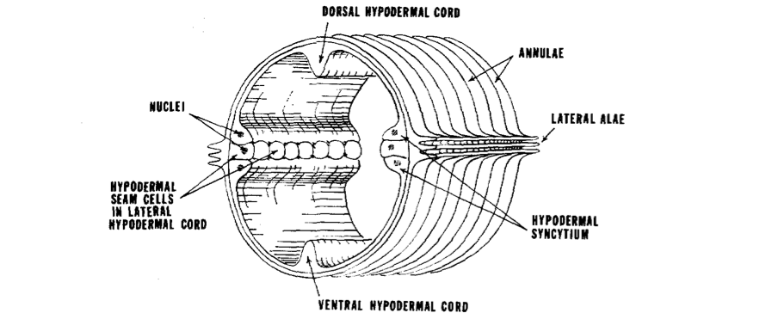
Image One: structure of the C. elegans cuticle (Cox et al., 1980).

Collagens are structural proteins and are the main compositional element of the nematode cuticle, giving it flexibility, strength, and resiliency. Collagens are ubiquitous in organisms, found in both prokaryotes and eukaryotes, always playing a key structural role either intracellularly or extracellularly. Most collagens exhibit a distinct tertiary structure called a “coiled coil” where multiple polypeptide chains wrap around each other, forming a helical structure that is highly stable. The structure and stability of collagen proteins are what allow it to be such a powerful and evolutionarily dominant molecule (Garrett, Grisham, 2012).

The human collagen protein, encoded by gene COL10A1, produces the alpha chain of the type X collagen, which is expressed during endochondral ossification (Wallis et al., 1996). This collagen is plays a distinct role in human movement. Mutations in the COL10A1 gene will produce a distinctive phenotype commonly referred to as dwarfism. This particular type of dwarfism, Schmid metaphyseal chondrodysplasia, named for its discoverer, was first categorized in 1949. Schmid noted afflicted individuals exhibited shorter, curved limbs with wider metaphysis and growth plates and that the phenotype is heritable. When this gene is mutated, the tertiary structure of the complete collagen protein is inhibited, which leads to a deficiency of this type X collagen, required for proper osseous tissue growth (Wallis et al., 1996).

The relevance of the COL10A1 gene to nematode movement is the homolog present in the C. elegans genome. The rol-1 gene in C. elegans encodes a collagen that is expressed during cuticle production of the adult stage (Kramer et al., 1990). Upon mutation of this gene, the cuticle formation is complete, but lacks a collagen for support, which causes the cuticle and internal organs of the worm to be helically twisted, producing a left-roller phenotype (Cox et al., 1980).

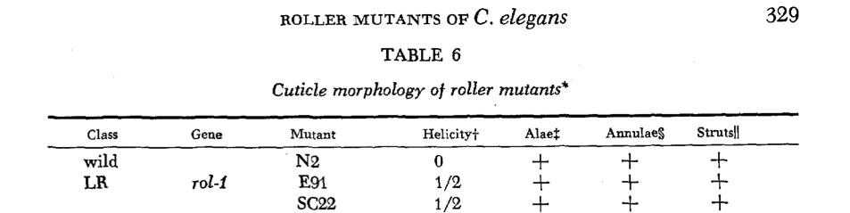
IMAGE TWO: morphology of the ROL-1 gene and its mutants (Cox et al., 1980).

The rol-1 gene is one of 14 genes involved in functional cuticle formation. Another gene causing the roller phenotype is rol-6, which causes a right-handed roller. As shown in the complete classification of roller mutants below, one strain of the rol-6 mutants has a highly altered phenotype: its body’s helix contains two complete twists, its alae have loops, and its anulae are slightly deranged (Cox et al., 1980).

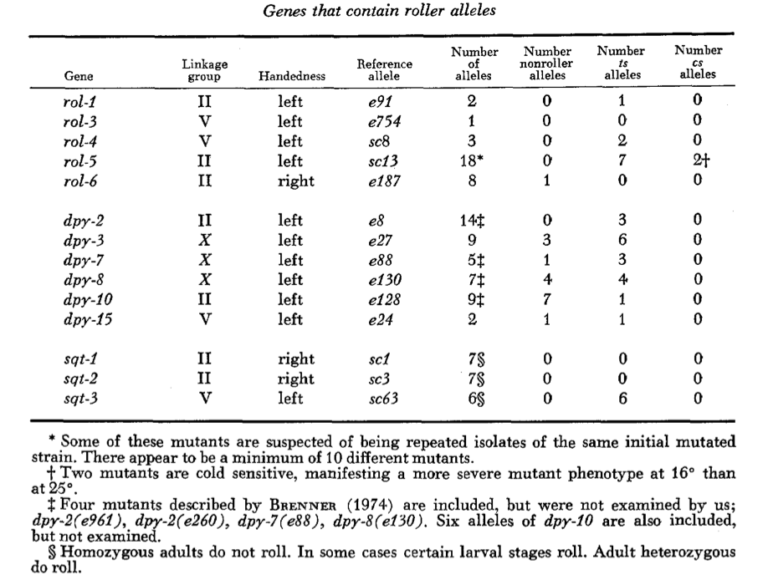
Image Two: classification of genes causing the roller in C. elegans (Cox et al., 1980).

The aforementioned rol-6 gene also encodes a collagen dire to the development of the cuticle (Kramer et al., 1990). Given the dramatic effects the mutation has on the morphology of the worm, it suffices to say that this collagen is rather influential on cuticle formation (Kramer, Johnson; 1993). The rol-6 gene has a human homolog that is also very influential on development: COL3A1, which is found on chromosome 2 (WormBase). The protein produced by COL3A1, as implied by the name, is a type III alpha 1 collagen. This collagen is found extensively throughout the human body; it is found in dermal, cardiovascular, organ, and bone tissue (NCBI, 2012). Mutations in the COL3A1 gene result in Ehlers-Danlos syndrome type IV or with aortic and arterial aneurysms (NCBI, 2012). In Ehlers-Danlos syndrome (EDS) type IV, afflicted individuals lack type III collagen that leads to deformation in specifically the vascular tissue – blood vessels and organs become very fragile and can easily tear or rupture (PubMed Health).

The prevalence of human homology in the corresponding genes to the roller phenotype illustrates how useful research in the movement pathway is. Understanding how these genes affect C. elegans will help us better understand how the homologs present in our genome affect us. With such similarity between nematode and human movement genes, we can gain a better understanding of the genetic disorders resulting from these newly understood mutations.

RESEARCH DESIGN
In our experiment, we will take a set of Caenorhabditis elegans and expose them to EMS and by doing so, create mutations in their germ line cells. We will then take individuals of the parent generation and place one nematode on its own plate – this will be done for five plates to be labeled P0-A[15] (Parent 0, A plate, worm number). This method will allow us to directly observe the progeny of an individual worm and thus learning exactly what mutations it undertook from the EMS treatment. After producing a number of offspring, the parent worms will be moved to a second individual plate, to be labeled P0-B[15]. Another set of progeny will be spawned on these B plates, independent of the worms on the A plate. This will provide more offspring, which will increase the probability of finding mutant offspring and will eliminate ambiguity by having two sets of progeny on one plate. After reproducing for this second time, the P0 generation will be killed.

In order to more easily move the F1 worms to a new plate, we will allow them to grow for 1-2 days on the P0 plates before transferring five to seven of them to plates labeled F1-[A/B][15]. The worms will be moved to plates corresponding to their parent; for example, worms from plate P0-A1 will be moved to F1-A1. Moving five to seven worms will establish a decent population of F1 progeny without requiring excessive time for translocation or overpopulating the plate, which would result in exhaustion of the food source. On these F1 labeled plates, worms will be allowed to lay eggs to produce an F2 offspring. After these eggs are produced, the F1 adults will immediately be killed.

The F2 generations will be screened after hatching. If any mutant phenotype is identified, the worm displaying the phenotype will be moved to its individual plate, to be labeled F2-[A/B][15] (annotations will be made in a notebook listing the observed), again depending on its ancestry. This process will be repeated for as many mutants as we are able to identify. Here, the F2 generation will be allowed to produce offspring and will subsequently be killed as to not cross the F2 and F3 generations. The production of an F3 is done to completely ensure heredity of the mutations originally induced by the exposure of EMS to the P0 zero generation. The F3 worms will be screened for the mutation that it should possess. If the worm does indeed exhibit the mutant phenotype, it will be documented and reported.

INSTRUMENTS
Worms will be grown on petridishes supplemented with Nematode Growth Media (NGM) with a lawn Escherichia coli strain OP50 for a food supply. This OP50 bacterial strain is a non-pathogenic auxotroph and will not be able to grow outside of the NGM plates. Worms will be transferred using a small platinum wire that possesses the ability to be flamed often and maintain durability. Plates will be stored in a sealed plastic bag within a shoe box that will be held in our group’s small locker. These precautions will be taken to reduce the possibility of contamination from mold or other bacteria.

PROCEDURE
On day one, we will take 5 of a population P0 worms, previously mutagenized by EMS, and place them on 5 individual plates labeled P0-A[15]. These worms will produce offspring and will be moved to plates P0-B[15]. After hatching and growing to at least L3, five to seven of the F1 from each plate will be moved to new plates labeled F1-[A/B][15], corresponding to the plate from which they came. These F1 worms will be allowed to grow, produce offspring, and then be killed. The F2 will be screened for mutants. Any mutants found will be moved to plates labeled F2-[A/B][15], allowed to reproduce, and then will be killed. Any F3 progeny displaying a mutant phenotype will be documented and reported. F3 generation will grow on the F2-[A/B][15] plate and will not be transferred unless it does, in fact, posses genetic mutation.

EXPECTED RESULTS
We expect to produce a mutagenized F3 generation displaying a variety of phenotypes. As these mutations will be completely random, we cannot aver as to what phenotypes will be identified in the F3 worms. We do, however, hope to produce mutants afflicted with a mutation that causes the roller phenotype.

These roller mutants will be studied to illuminate the movement pathway of nematodes, if found, that is. DNA will be extracted and compared to N2 wild type C. elegans DNA in effort to identify missing or modified genes. If the hypothesized genes are found in the mutants, we will confirm the mutations via RNAi. The mutant DNA, after identification, will be used to create a foreign RNA, which will then be placed in a media. Wild type worms will then be grown on this experimental media. After growth, if they exhibit the same mutations as the F3 generation produced in the original experiment, we will have identified the mutation causing the desired roller phenotype. With this information, we will gain a better understanding of the movement pathway that causes this mutation.

BIBLIOGRAPHY

1. Cox, George N., John S. Laufer, Meredith Kush, and Robert S. Edgar. "GENETIC AND PHENOTYPIC CHARACTERIZATION OF ROLLER MUTANTS OF CAENORHABDITIS ELEGANS." Genetics 95.21 June (1980): 317-39. Web. 5 Nov. 2012. <http://www.genetics.org/content/95/2/317.short>.
2. Page, Antony P., and Iain L. Johnstone. "The Cuticle." WormBase. N.p., n.d. Web. 5 Nov. 2012. <http://www.wormbook.org/chapters/www_cuticle/cuticle.pdf>.
3. Garrett, Reginald H., and Charles M. Grisham. Biochemistry. 5th ed. Belmont, CA: Brooks/Cole, 2012. Print.
4. Wallis, George A., B Rash, B Sykes, J Bonaventure, and P Maroteaux. "Mutations within the gene encoding the alpha 1 (X) chain of type X collagen (COL10A1) cause metaphyseal chondrodysplasia type Schmid but not several other forms of metaphyseal chondrodysplasia." Journal of Medical Genetics 33.6 (1996): 450-57. Web. 6 Nov. 2012. <http://jmg.bmj.com/content/33/6/450.full.pdf+html>.
5. WormBase Site. US NIH and British MCR, n.d. Web. 6 Nov. 2012. <www.wormbase.org>.
6. Kramer, J M., R P. French, E C. Park, and J J. Johnson. "The Caenorhabditis elegans rol-6 gene, which interacts with the sqt-1 collagen gene to determine organismal morphology, encodes a collagen." Molecular and Cellular Biology 10.5 May (1990): 2081-89. Web. 5 Nov. 2012. <http://mcb.asm.org/content/10/5/2081.full.pdf+html>.
7. Kramer, J M., and J J. Johnson. "Analysis of Mutations in the sqt-1 and rol-6 Collagen Genes of Caenorhabditis elegans." Genetics 135.41 Dec. (1993): 1035-45. Web. 6 Nov. 2012. <http://www.genetics.org/content/135/4/1035.short>.
8. "COL3A1 collagen, type III, alpha 1 [ Homo sapiens ]." National Center for Biotechnoloy Information. National Institutes of Health, n.d. Web. 6 Nov. 2012. <http://www.ncbi.nlm.nih.gov/gene/1281#HIV-1-protein-interactions>.
9. "Ehlers-Danlos syndrome." PubMed Health . Ed. David C. Dugdale. National Institutes of Health, n.d. Web. 6 Nov. 2012. <http://www.ncbi.nlm.nih.gov/pubmedhealth/PMH0002439/>.

