Lauren Griffith

BIOL 3452.502

TA: Mary Ladage

Proposal: Forward Genetic Screen

of Caenorhabditis Elegans

*Due: November 9, 2012*

Table of Contents

**Abstract** 3

*Figure1*: Anatomy of Caenorhabditis Elegans 4

**Introduction** 5

*Figure 2*: A Simple $F3$ Screen 6

**Method & Specific Aim** 7

Research Design 7

Instruments 8

Procedure 10

*Figure 3*: Structure of the Mutagen- Ethyl Methanesulfonate 11

*Figure 4*: Worm Pick a) Image and b) Creation 11

*Figure 5*: A Dissecting Microscope 12

**Expected Result & Discussion** 13

Bibliography 16

# Abstract

The Genetics Laboratory for course number BIOL3452.502 is to conduct a *forward genetic screen* on the roundworm Caenorhabditis Elegans. A *forward genetic screen[1]* involves the observation of a phenotype of interest within a mutagenized germline. Group 2 has chosen to study movement related traits by isolating *rol-9 (sc148)V* mutants, i.e. *rollers[2]*. A mutagenized population, the $P_{0}$ generation, will be acquired and allowed to reproduce for three subsequent generations. The $F_{2}$ generation of this test group will then be screened for the *roller* mutation. The progeny of these $F_{2}$ rollers, the $F_{3}$ generation, will yield the most integral data of our study. By studying these *rollers*, we hope to better understand the genes involved in movement for Caenorhabditis Elegans. The ways in which the roller mutation effects movement may be the result of *rol-9*’s role (no pun intended) in a greater genetic/chemical system dictating motility in Caenorhabditis Elegans[3]. How many $F_{3}$ nematodes manifest the *roller*  will also lend context to the way such a mutation is inherited and thus further expand our knowledge of the mutation’s relationship to other alleles of the *rol-9* gene.

Figure1: Anatomy of Caenorhabditis Elegans***[4]*** 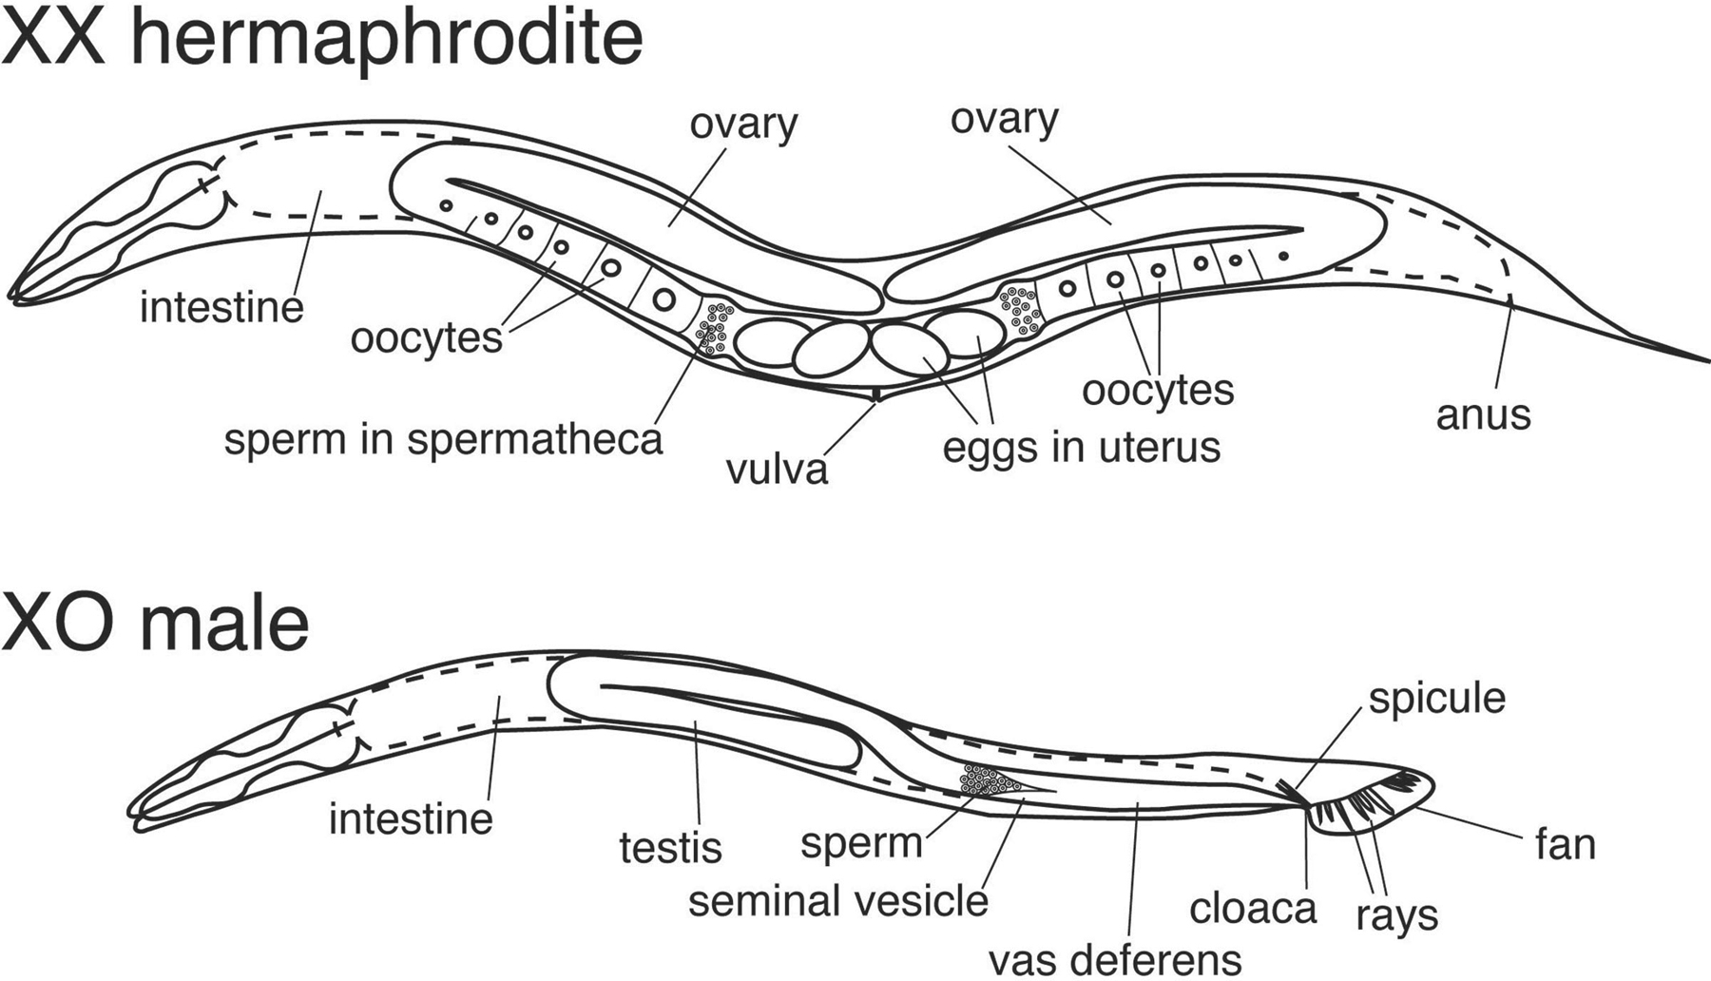

# Introduction

As a result of Sydney Brenner’s paper, *The Genetics of C. Elegans[5],* Caenorhabditis Elegans has become one of the primary model organisms used in genetic research. Its use has thus proliferated because of C. Elegan’s many favorable morphological and genetic characteristics: short reproductive cycle, tractability, small adult size, observable phenotypes and wide availability[6]. In 1974, Brenner detailed a process called the *Genetic Screen* to discover “how genes might specify the complex structures found in higher organisms.[7]” His process involved the observation of specific gene mutations to study the mechanics of larger genetic/chemical systems. This approachhas transformed our modern understanding of the molecular mechanisms of gene expression by illuminating the genetic pathways which regulate complex biological functions. Ceanorhabditis Elegans is especially valuable in *Genetic Screens* because its “hermaphroditic lifestyle and rapid generation time make it suitable for the isolation and characterization of genetic mutants.[8]”

In his studies, Brenner identifies and characterizes a wide variety of mutations for C. Elegans, most of which have a visible phenotypic manifestation[9]. Visible mutations, such as those that effect behavior, are ideal for the simple screens our lab will be preforming[10]. This type of *Genetic Screen* requires us to expose a population of worms to a mutagen, ours being ethyl methanesulfonate (EMS). EMS works by adding alkyl groups to the nucleotides of DNA molecules, transforming guanine so that it forms hydrogen bonds with thymine[11]. This base mis-pairing causes random point mutations within the genetic code. The mutagenized worms are allowed to reproduce and their offspring is subsequently screened for visible mutations. In our *forward genetic screen*, we will be focusing on the visible *roller* mutation of the *rol-9* gene.

## Figure 2: A Simple $F_{3}$ Screen[12]



# Method & Specific Aim

## Research Design

A genetic screen can bridge the gap between genotype and phenotype. By studying *rollers* in a mutagenized population of Caenorhabditis Elegans, we hope to further our understanding of the genetic systems of motility. The type of screen our laboratory can carry out has notable limitations; but, by extrapolating from previously observed (as well as our own) data of mutated $F_{3}$ nematodes, we may adequately compensate for our gaps in knowledge and control. One notable gap in control originates in the random nature of mutation by EMS in our $P_{0}$ population. We cannot guarantee that our phenotype of choice will manifest at all. Furthermore, how many distinct gene mutations are needed to cause that particular phenotype affects the probability of its manifestation (especially in the case of EMS’s random point mutations). If the number of gene constituents involved in a mutation is unknown, the percentage of individuals that show that phenotype may vary significantly from the predicted value. There is also the chance that a single gene mutation in consort with other specific gene mutations, respectively, could cause differing phenotypes. In that way, the interactive nature of gene products may obscure the connection between phenotypes and specific gene mutation. We may attempt to disambiguate our findings by studying the already compiled data concerning mutations in Caenorhabditis Elegans.

Apart from the previously stated theoretical restrictions, working with Caenorhabditis Elegans has various physical limitations. Their nutrient source specifically causes problems that must be compensated for in our procedure. A judicial use of a Bunsen Burner, as well as latex gloves, whenever worms are transferred or observed is important to prevent the E. Coli from infecting laboratory students. Also, regulating the worm’s population size is essential to maintaining adequate populations of E. Coli for our test subjects. Students must also take great care not to breathe on or otherwise contaminate the E. Coli population in order to prevent bacterial infection on the agar plates. A sterile working environment is vital to the accurate completion of our *forward genetic screen* on Caenorhabditis Elegans.

## Instruments

* Nematode Strains

The N2 strain of Caenorhabditis Elegans is the chosen model organism for this forward genetic screen[13]. Five worms are to be selected from the original mutagenized N2 population to participate in our experiment. Their progeny will thereafter be organized and the quantity denoted by the experimental step in which they are involved.

* Media

Caenorhabditis Elegans is best grown on *Nematode Growth Medium* (NGM) “that has been aseptically poured into petri plates[14].” There will be a total of 30 plates used in our execution of the *forward genetic screen.* In order to sustain these organisms, NGM plates are then “seeded” with E. coli bacteria of the OP50 strain (nonpathogenic)[15]. Great care must be taken to maintain the sterility in all procedures of the *forward genetic screen*. In order to prevent contamination of the media (and ourselves) it is important that all students wear latex gloves and make use of the Bunsen burner while handling the plates.

* Maintenance of Stocks

In order to maintain the worm stocks, students must regulate the size of C. Elegans populations on the plates. Keeping the number of worms low prevents them from consuming all of the E. coli too early and starving to death. It is important to note that the higher the room temperature, the faster C. Elegans can reproduce[16]. The efficiency of the experiment, therefore, depends on closely monitoring the ambient temperature of our work space (should be from 20-25 degrees celcius). We must also take into account that embryogenesis can take up to 3-4 days at 20 degrees Celsius[17]. It takes wild type worms until 3-4 days into their lifecycle to begin laying eggs[18].

* Induction of Mutation with Ethyl Methanesulfonate

For the purpose of our *forward genetic screen*, mutations are induced in the N2 C. Elegans population by exposing them to Ethyl Methanesulfonate (EMS). EMS works by altering guanine so that it forms hydrogen bonds with thymine. This base mis-pairing causes random point mutations in the DNA of C. Elegans. *Figure 3* shows the structure of Ethyl Methanesulfonate.

* Handling and Observing the Animals

A worm pick must be used when moving worms from one location to another, illustrated in *Figure 4*. This pick is made by “adhering an approximately 1.0-inch piece of 32 gauge platinum wire into the tip of a glass pasture pipet.[19]” The platinum wire has a very low heat index and, therefore, heats/cools very quickly. This characteristic allows for easy sterilization by running the tip through a Bunsen Burner while moving the worms from place to place, further facilitating the sterility of our work station. In order to properly visualize the process of worm picking, the student must use a dissecting microscope (*Figure 5)*. The actual techniques used to relocate nematodes seem to be quite personal, but they always involve some variation of lightly scooping the worm onto the pick. Once the worm is safely on the pick, it must quickly be placed onto another plate. If this transfer does not happen in a timely manner, the worm is likely to desiccate on the pick.

## Procedure

The first step in our project involves acquiring a mutagenized population of C. Elegans to act as the Parental, $P_{0}$, Generation. Five $P_{0}$ nematodes are to be selected and placed on five separate agar plates. Once the $P_{0}$ has laid eggs on the first set of plates, they are to be transferred to a second set of five agar plates and allowed, again, to lay eggs. These first two sets of plates will be labeled $P_{0}A_{1-5}$ and $P_{0}B_{1-5}$, respectively. A period of 12-24 hours will allow the worms to lay eggs. The subsequent maturation period should be limited to 1-2 days. This permits adequate growth for the purposes of the *forward genetic screen* and also prevents excessive cross-generational mating (which would contaminate the results of our screen). Once the $P_{0}$ generation has been allowed to reproduce on both plates, they are to be disposed of through desiccation in the Bunsen Burner. (Padilla 2012)

The third and fourth sets of plates are the $F_{1}A_{1-5}$ and $F_{1}B_{1-5}$ plates. Once the $F_{1}$ offspring of our $P_{0}$ nematodes have matured on both the $P_{0}A_{1-5}$ and $P_{0}B_{1-5}$, one worm from each plate is transferred to the $F_{1}A$ or $F_{1}B$ plate of a corresponding number. These $F_{1}$ worms are also allowed to lay eggs for a period of 12-24 hours before they too are desiccated. These $F_{2}$,eggs, are then allowed to mature for 1-2 days before they are screened for the phenotype of interest. We will isolate the *roller* mutants from the $F_{1}A_{1-5}$ and $F_{1}B_{1-5}$ plates and transfer them to $F_{2}$ plates, where they will be given time to lay eggs. This process, again, will take 12-24 hours, upon which time you will desiccate the $F_{2}$ generation. These newest eggs represent the $F_{3}$ generation, who are the true focus of our study. Our main objective would then be to analyze whether the $F_{3}$ generation manifests our chosen mutation. The presence or absence of a *roller* mutation in our $F_{3}$ generation will inform specific characteristics of the genotype, phenotype, and the mutation’s relationship to other alleles. (Padilla 2012)

## Figure 3: Structure of the Mutagen- Ethyl Methanesulfonate

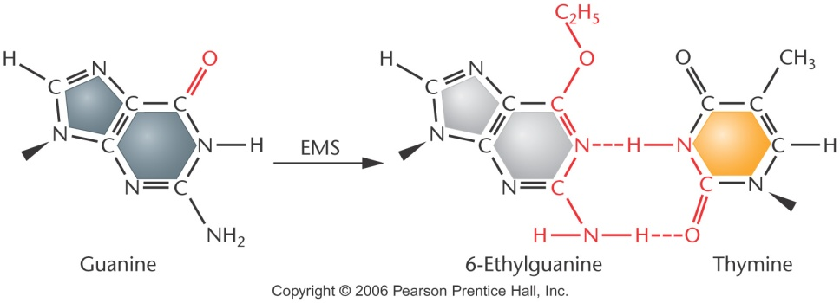[20]

## Figure 4: Worm Pick a) Image and b) Creation

1. 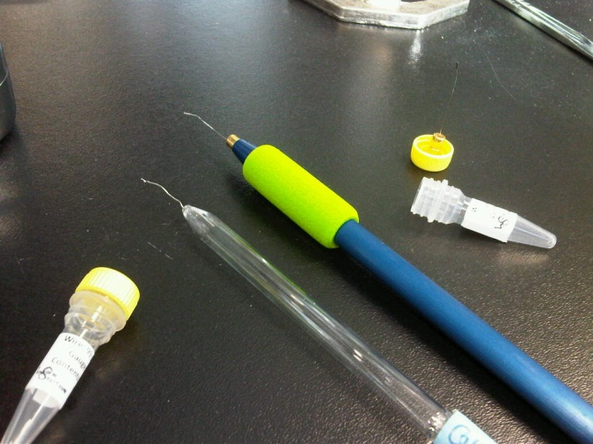[21]
2. *Creating a Worm Pick:*

“The pick is made by adhering an approximately 1.0-inch piece of 32 gauge platinum wire into the tip of a glass Pasture pipet. This is accomplished by heating the glass so that the wire is embedded into the glass… The end of the wire, used for picking worms, can be flattened slightly with a hammer and then filed with an emery cloth [or razor] to remove sharp edges; sharp points can poke holes in the worms and kill them or make holes in the agar. The tip of the wire can be fashioned to your liking. Some people prefer a flattened end, while others prefer a slight bend that forms a hook.[22]”

## Figure 5: A Dissecting Microscope

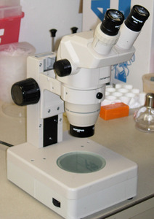[23]

# Expected Result & Discussion

Through the careful execution of a *forward genetic screen* on Caenorhabditis Elegans, Genetics Lab Group #2 will acquire a better understanding of the “relationship between gene, allele, wild-type and phenotype.[24]” Our hypothesis is that by isolating *roller* mutants of the *rol-9* gene in C. Elegans we will be able to glean further information concerning the genetic mechanisms influencing motility in that organism. Observing the $F_{3}$ progeny will elucidate the mode of inheritance of the roller mutation, i.e. its relationship to the other *rol-9* alleles. We will study the phenotype of all resulting $F_{3}$ progeny to understand how the gene is passed from parent to offspring. *Figure 2[25]* (on pg. 6) shows that, of the worms that possess a *roller* allele, 50% of the $F_{2}$ generation will be of the m/+ genotype and another 25% will be m/m. If the m/+ heterozygote displays the *roller* phenotype, it will be picked and included in the ultimate $F_{3}$ screen. Because we know that an m/m mutant displays the *roller* phenotype, we can speculate that, if the m/+ worms are included in the selected $F_{2}$*rollers,* the ratio of offspring that demonstrate the mutation will be altered fundamentally. If the mutation is recessive (only the m/m mutants manifest the phenotype) all of the $F_{3}$ offspring will demonstrate the *roller* phenotype. If the mutation is dominant (both the m/+ and m/m mutants manifesting the phenotype) there will be occurrences of the wild-type within the $F_{3}$ progeny. Because it would be very difficult to maintain an accurate quantitative figure for our purposes, we will most likely be limited to denoting the mutation’s allelic relationship in the simplest dominant/recessive form.

Through further screens and analysis, the “*molecular characteristic* of the mutant allele…can be mapped and sequenced.[26]” Executing PCR analysis coupled with Gel Electrophoresis will allow us to understand the nature of the aberrant code within the *roller* mutants. Whether the *rol-9* gene has a longer or shorter base sequence in wild type worms than in mutants will tell us whether the mutation is a substitution or deletion. If there is no difference in the molecular size of the two alleles, the mutation is likely the result of base mis-pairing. Because we know the manner in which these samples were mutagenized (using EMS to induce base mis-pairing); I project that, unless a certain mutation arises from base mis-pairing, it most likely will not manifest in our mutagenized population. A different mutagen may be necessary to study gene mutations that are the result of substitutions and deletions.

Once that data has been tabulated, the mutant and wild type gene products (RNA and Proteins) may be compared, lending insight into the requirements of functional motility in Caenorhabditis Elegans. These studies give us the ability to “discover and understand gene function relative to biological processes.[27]” A BLAST (Basic Local Alignment Search Tool[28]) search will also reveal connections between regulated motility in C. Elegans and humans. Though movement is regulated by a slightly more complex system in humans, mammals are extremely genetically fragile. The kingdom Animalia is notoriously intolerant of genetic variation and, if the *rol-9* gene in C. Elegans has a human counterpart, it is most likely quite important to our functionality. Through studies of the *roller* mutation in these nematodes, we may discover that it causes lethality in humans or is involved in any number of tangential disorders. Caenorhabditis Elegans has the capability of housing some of the most deleterious mutations that arise in our human populations. They are easily studied through observable phenotypes in viable offspring. There is enormous potential to learn about ourselves by observing these consistently durable organisms.

# Bibliography

1. Padilla, Pamela. University of North Texas Biology 3452: Genetics Laboratory Manual Fall 2012. Denton, TX: Copy Pro Copy Center, 2012.
2. Zarkower, David. WormBook:The Online Review of C. Elegans Biology, "Somatic Sex Determination." Last modified 2006. Accessed November 2012.
3. Brenner, Sydney. "The Genetics of Caenorhabditis Elegans." Medical Research Council Laboratory of Molecular Biology,. (1973): 71-94.
4. Jorgensen, Erik, and Susan Mango. "The Art and Design of Genetic Screens: C. Elegans." Nature Reviews. 3. (2002): 356-369.
5. Klug, William, Michael Cummings, Charlotte Spencer, and Michael Palladina. *Concepts of Genetics*. San Francisco: Pearson Education, 2012.
6. Wormbase.org, "Worm Community Forum." Last modified 2012. Accessed November 2012. <http://forums.wormbase.org/index.php?topic=1706.0>.
7. Laboratory for Optical and Computational Instrumentation at the University of Wisconsin-Madison, "WormClassroom: C. Elegans Cultivation." Last modified 2012. Accessed November 2012. http://www.wormclassroom.org/c-elegans-cultivation.

1. Pamela Padilla, University of North Texas Biology 3452: Genetics Laboratory Manual Fall 2012, (Denton, TX: Copy Pro Copy Center, 2012), 67-75.
2. Pamela Padilla, University of North Texas Biology 3452: Genetics Laboratory Manual Fall 2012, (Denton, TX: Copy Pro Copy Center, 2012), 67-75.
3. Pamela Padilla, University of North Texas Biology 3452: Genetics Laboratory Manual Fall 2012, (Denton, TX: Copy Pro Copy Center, 2012), 67-75.
4. Zarkower, David. WormBook:The Online Review of C. Elegans Biology, "Somatic Sex Determination." Last modified 2006. Accessed November 2012.
5. Sydney Brenner, "The Genetics of Caenorhabditis Elegans," Medical Research Council Laboratory of Molecular Biology, (1973): 71-94,
6. Pamela Padilla, University of North Texas Biology 3452: Genetics Laboratory Manual Fall 2012, (Denton, TX: Copy Pro Copy Center, 2012), 67-75.
7. Sydney Brenner, "The Genetics of Caenorhabditis Elegans," Medical Research Council Laboratory of Molecular Biology, (1973): 71-94,
8. Erik Jorgensen, and Susan Mango, "The Art and Design of Genetic Screens: C. Elegans," Nature Reviews, 3 (2002): 356-369
9. Sydney Brenner, "The Genetics of Caenorhabditis Elegans," Medical Research Council Laboratory of Molecular Biology, (1973): 71-94,
10. Erik Jorgensen, and Susan Mango, "The Art and Design of Genetic Screens: C. Elegans," Nature Reviews, 3 (2002): 356-369
11. Pamela Padilla, University of North Texas Biology 3452: Genetics Laboratory Manual Fall 2012, (Denton, TX: Copy Pro Copy Center, 2012), 67-75.
12. Erik Jorgensen, and Susan Mango, "The Art and Design of Genetic Screens: C. Elegans," Nature Reviews, 3 (2002): 356-369
13. Pamela Padilla, University of North Texas Biology 3452: Genetics Laboratory Manual Fall 2012, (Denton, TX: Copy Pro Copy Center, 2012), 67-75.
14. Pamela Padilla, University of North Texas Biology 3452: Genetics Laboratory Manual Fall 2012, (Denton, TX: Copy Pro Copy Center, 2012), 67-75.
15. Pamela Padilla, University of North Texas Biology 3452: Genetics Laboratory Manual Fall 2012, (Denton, TX: Copy Pro Copy Center, 2012), 67-75.
16. Pamela Padilla, University of North Texas Biology 3452: Genetics Laboratory Manual Fall 2012, (Denton, TX: Copy Pro Copy Center, 2012), 67-75.
17. Pamela Padilla, University of North Texas Biology 3452: Genetics Laboratory Manual Fall 2012, (Denton, TX: Copy Pro Copy Center, 2012), 67-75.
18. Pamela Padilla, University of North Texas Biology 3452: Genetics Laboratory Manual Fall 2012, (Denton, TX: Copy Pro Copy Center, 2012), 67-75.
19. Pamela Padilla, University of North Texas Biology 3452: Genetics Laboratory Manual Fall 2012, (Denton, TX: Copy Pro Copy Center, 2012), 67-75.
20. Klug, William, Michael Cummings, Charlotte Spencer, and Michael Palladina. *Concepts of Genetics*. San Francisco: Pearson Education, 2012.
21. Wormbase.org, "Worm Community Forum." Last modified 2012. Accessed November 2012. http://forums.wormbase.org/index.php?topic=1706.0.
22. Pamela Padilla, University of North Texas Biology 3452: Genetics Laboratory Manual Fall 2012, (Denton, TX: Copy Pro Copy Center, 2012), 67-75.
23. Laboratory for Optical and Computational Instrumentation at the University of Wisconsin-Madison, "WormClassroom: C. Elegans Cultivation." Last modified 2012. Accessed November 2012. http://www.wormclassroom.org/c-elegans-cultivation.
24. Pamela Padilla, University of North Texas Biology 3452: Genetics Laboratory Manual Fall 2012, (Denton, TX: Copy Pro Copy Center, 2012), 67-75.
25. Erik Jorgensen, and Susan Mango, "The Art and Design of Genetic Screens: C. Elegans," Nature Reviews, 3 (2002): 356-369
26. Pamela Padilla, University of North Texas Biology 3452: Genetics Laboratory Manual Fall 2012, (Denton, TX: Copy Pro Copy Center, 2012), 67-75.
27. Pamela Padilla, University of North Texas Biology 3452: Genetics Laboratory Manual Fall 2012, (Denton, TX: Copy Pro Copy Center, 2012), 67-75.
28. Pamela Padilla, University of North Texas Biology 3452: Genetics Laboratory Manual Fall 2012, (Denton, TX: Copy Pro Copy Center, 2012), 64.